**SQL Task**

**Aim: Design at least 10 SQL queries for suitable database application using SQL DML statements: Insert, Select, Update, Delete with operators, functions, and set operator Problem Statement:**

**1. Create table Student with schema (roll_no, name, division, branch, city, marks)**

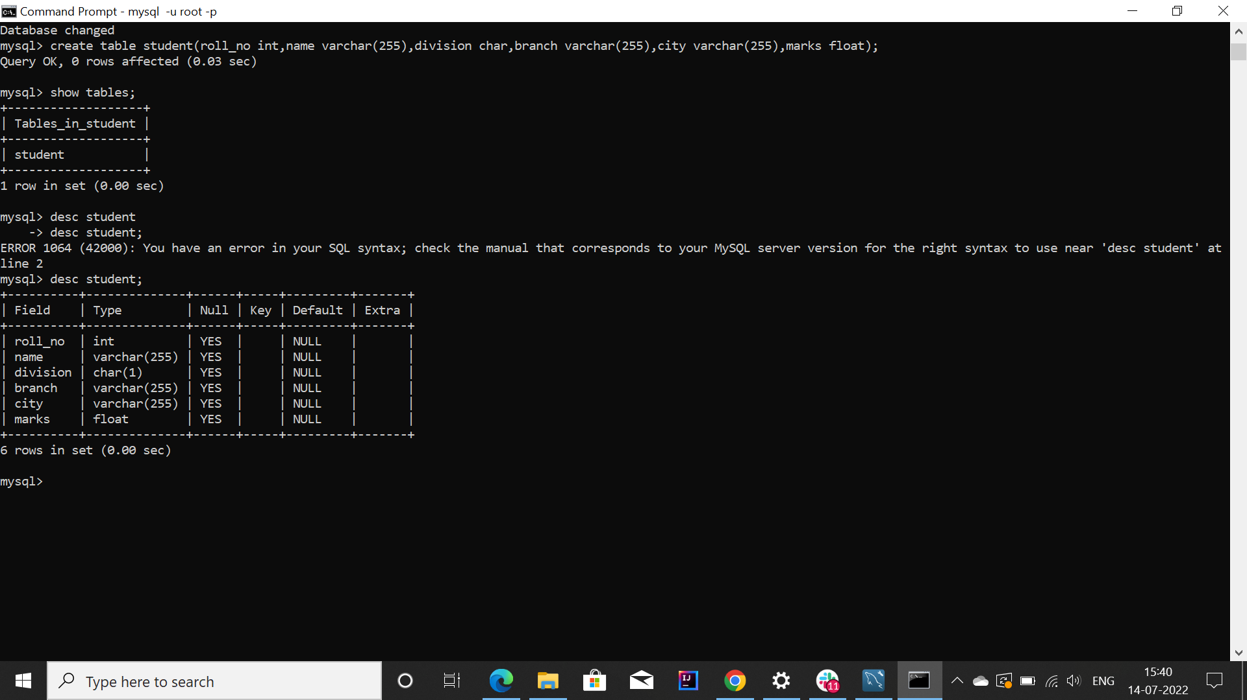

**2. Insert 10 records to the table students**

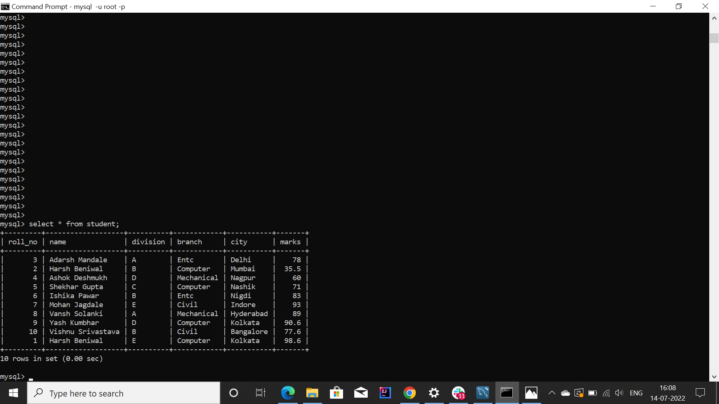

**3. List all the student names with their corresponding city**

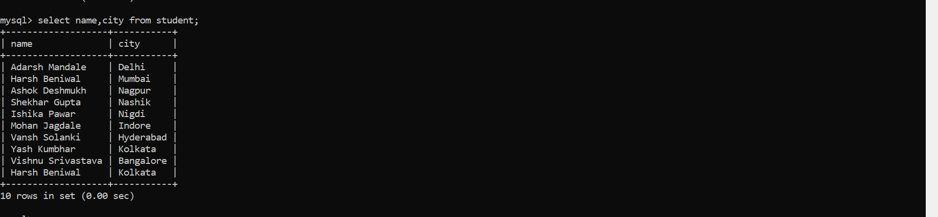

**4. List all the distinct names of the students**

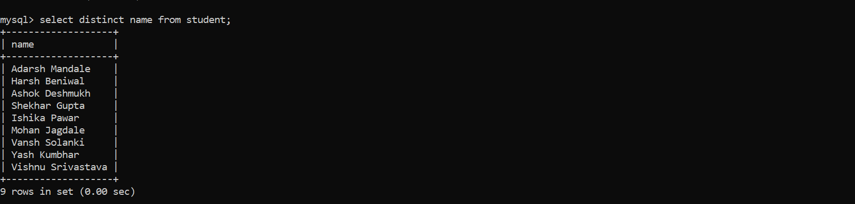

Note : Harsh Beniwal was a repeated name.

**5. List all the records of the students with all the attributes**

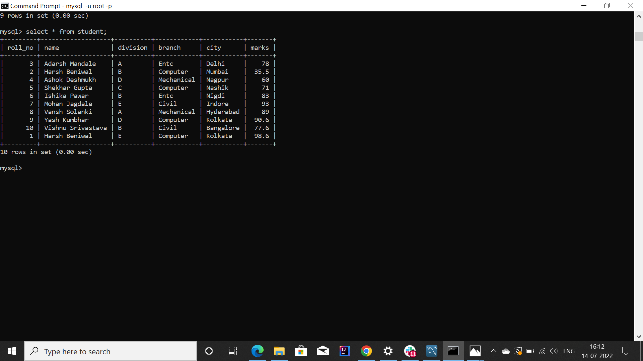

**6. List all the students whose marks are greater than 75**

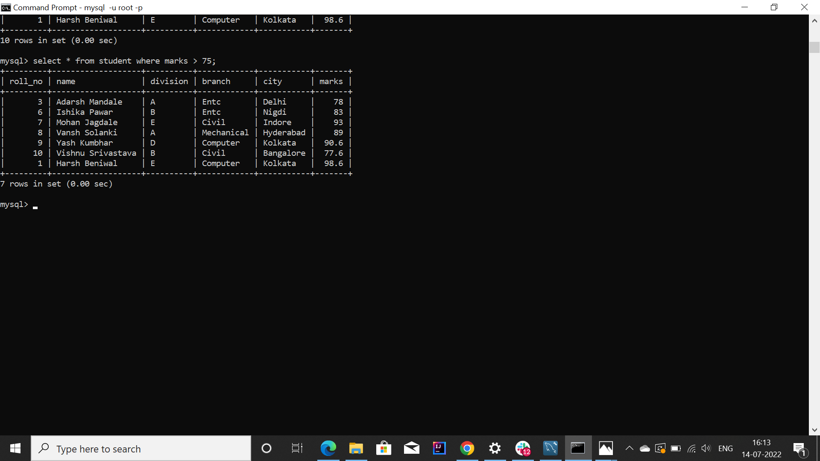

**7. List all the students whose name starts with the alphabet 'S**

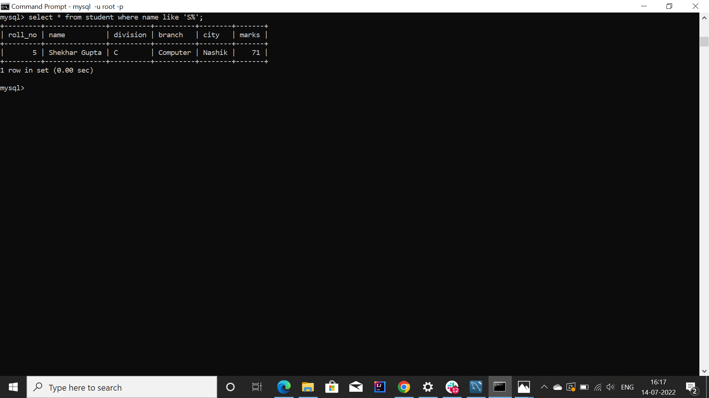

**8. List all the students whose marks are in the range of 50 to 60**

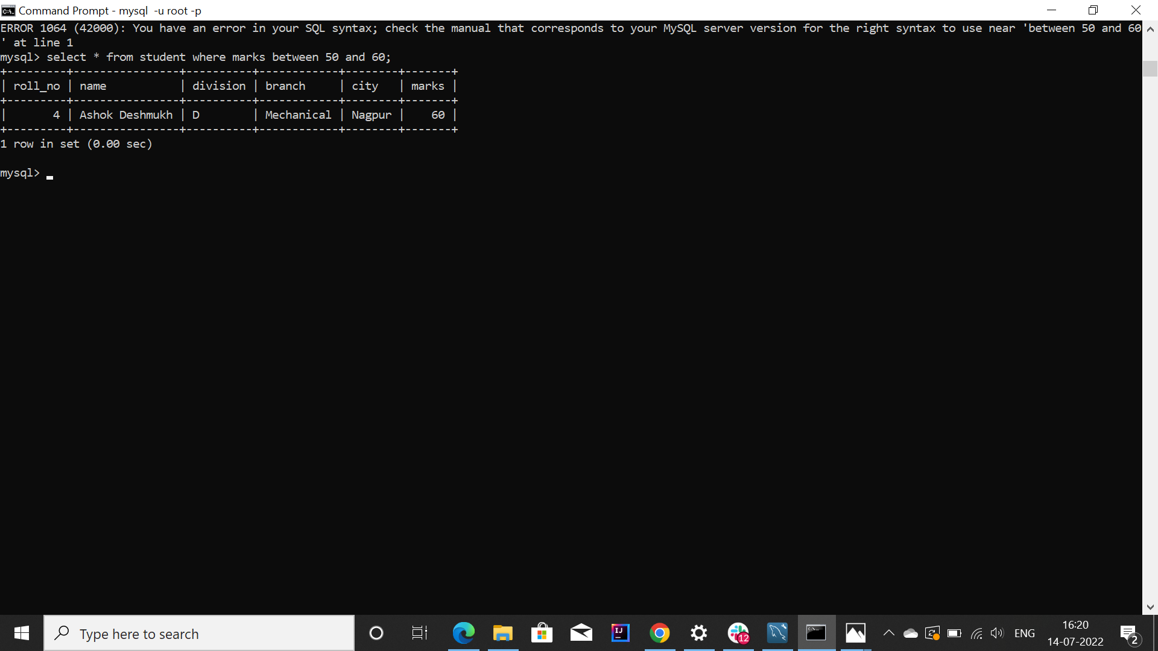

**9. List all the students whose branch is 'computer and city is 'Pune'**

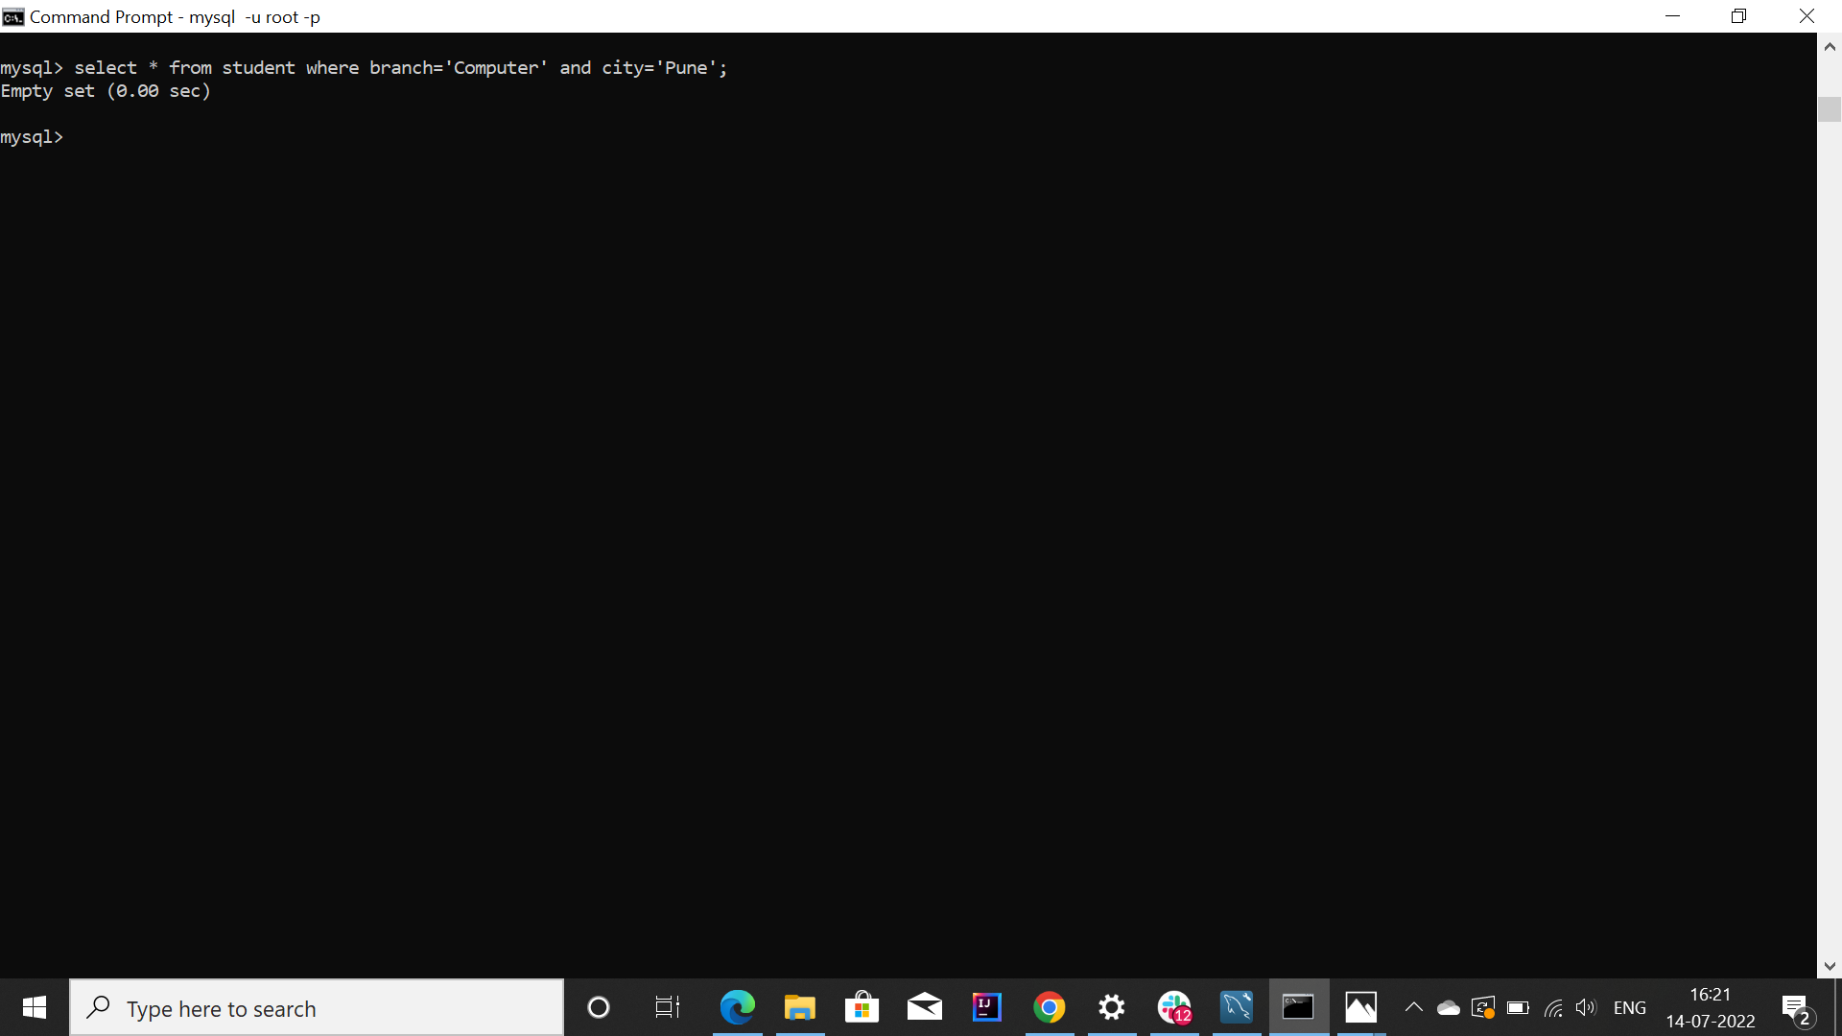

**10. Update the branch of a student to 'IT' whose roll number is 9**

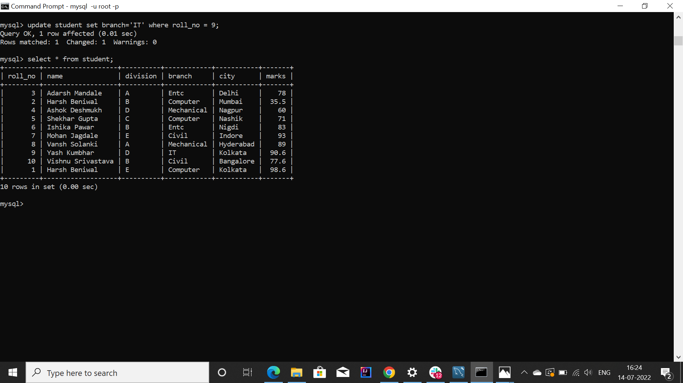

Note : Student named ‘Yash Kumbhar’ branch was changed.

**11. Delete the student records whose division is 'BE'**

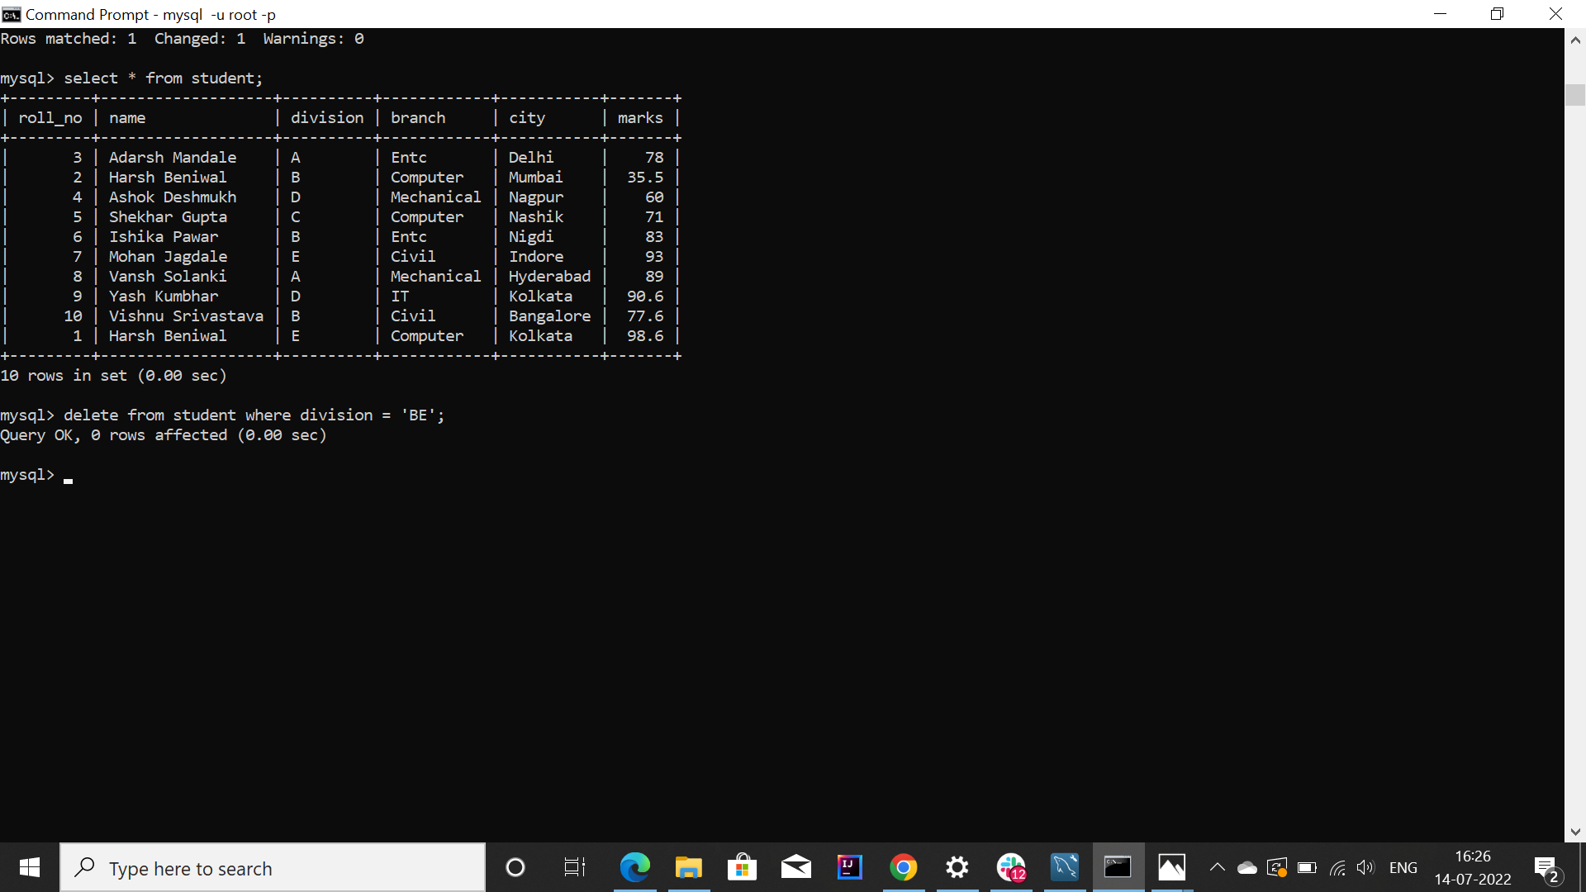

**12. Create another table TE_Students with Schema( roll_no, name)**

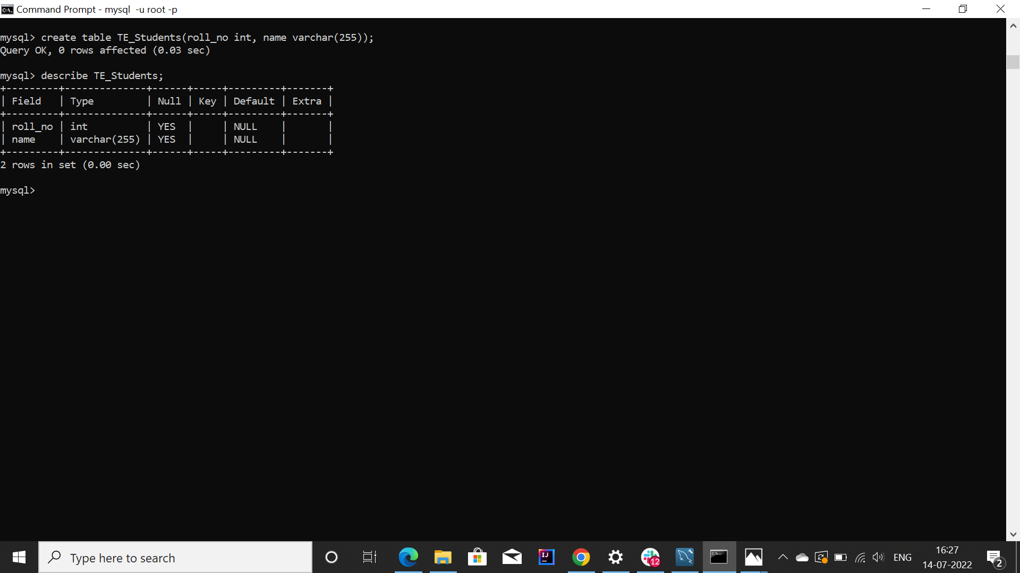

**13. List all the roll numbers unionly in the relations Student and TE Students**

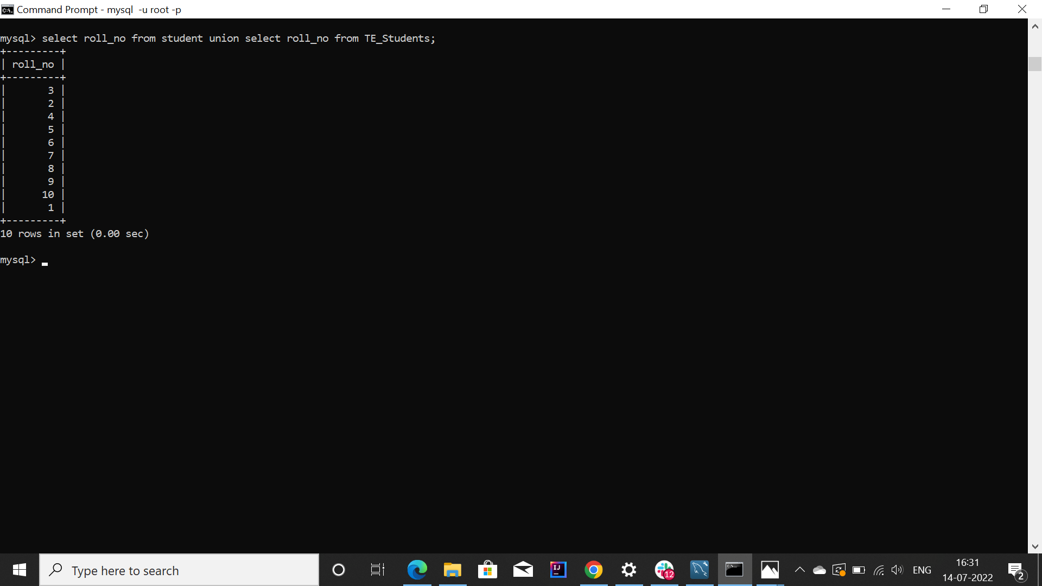

**14. Display name of all the students belonging to the relation Student in Upper Case.**

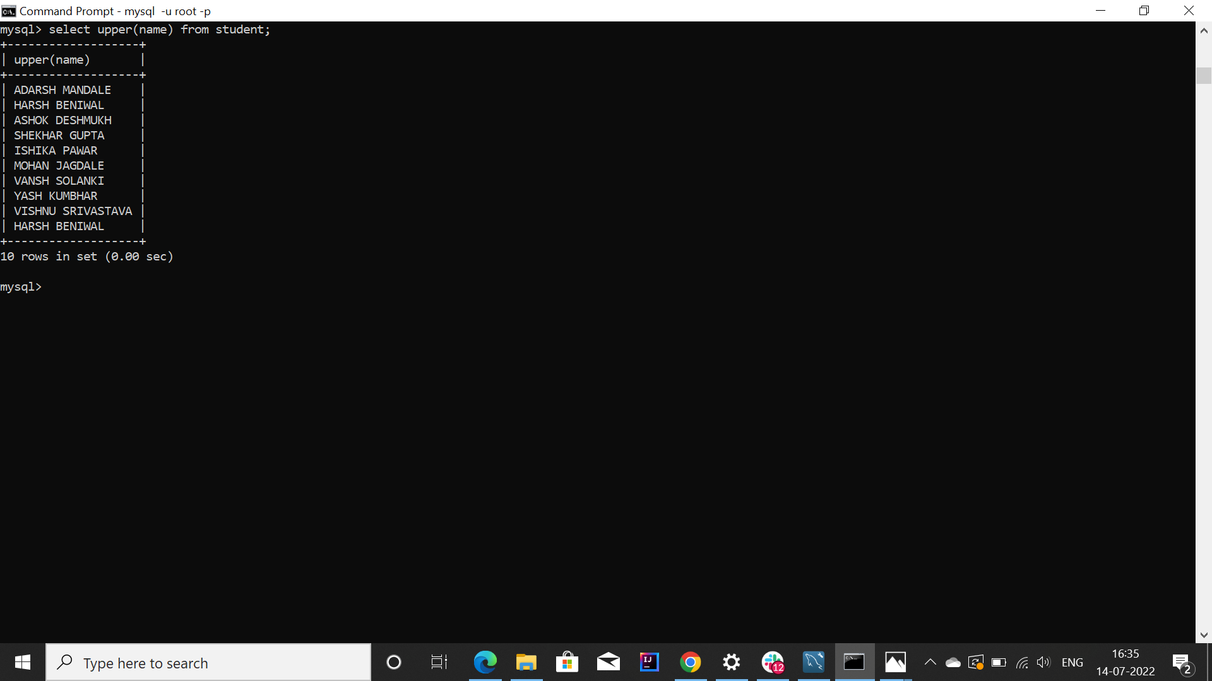

**15. Display the binary and hex equivalent of marks for all the students belonging to student relation.**

